Zachary Gray
PCB 6455 / BSC 4933: Biometry
Dr. Brian Maitner
10/13/2026
Midterm 1: Part 1

Ecology of Timber Rattlesnakes (Crotalus horridus) within Urbanized Landscapes of Southeastern Louisiana

Introduction
Timber rattlesnakes (Crotalus horridus) are among the most widespread members of Viperidae in the eastern United States (Martin, 1992). Populations within the southeastern U.S. primarily occur in intact hardwood forests, grasslands, and occasionally longleaf pine savannas (Rudolph and Burgdorf, 1997). While populations remain relatively stable throughout portions of the Southeast, threats such as habitat fragmentation, road mortality, and disturbances to overwintering structures are believed to contribute to local population declines and extirpations (Rudolph and Burgdorf, 1997; Rudolph et al., 1998). As urban development continues to fragment natural habitats, understanding how rattlesnake populations persist within increasingly modified landscapes is important for developing effective conservation and management strategies, particularly in portions of their range where declines are more significant (Clark et al., 2010). Despite extensive studies of C. horridus, comparatively little is known about factors supporting populations persisting within highly urbanized landscapes near the species' southern range extent. Urban environments introduce several ecological challenges for C. horridus, including increased human-wildlife interactions and habitat isolation, which may reduce gene flow between populations (Clark et al., 2010). However, some urbanized landscapes may also provide suitable habitat through artificial refugia and locally abundant prey populations, with anthropogenic resource subsidies potentially supporting greater population densities than would naturally occur within similarly sized habitats. Understanding how these conditions influence rattlesnake activity and habitat use may help explain why certain populations persist despite extensive surrounding development.
In this study, we examined C. horridus populations within the greater New Orleans region of southeastern Louisiana, focusing on relationships between environmental conditions and snake observations. Using data collected through visual encounters and transect surveys associated with artificial overwintering structures, we investigated patterns in rattlesnake detection across varying surface temperatures and survey methods. Additional morphological data, including sex and size class, were used to examine potential differences in detection patterns among individuals.

Materials and Methods
Field surveys of urban timber rattlesnake (Crotalus horridus) populations were conducted within the greater Jefferson Parish region of southeastern Louisiana between January 2022 and June 2026. A total of 341 surveys were conducted year-round under varying environmental conditions. Surveys consisted primarily of structural transects with occasional road transects, including searches of and the addition of new artificial overwintering structures designed to find thermal preferences. Transect sizes ranged from approximately 50–300 m in length, with our individual surveys lasting a minimum of four hours, with effort varying due to team availability. Surveys were conducted between 0800 and 1800 hours, with nighttime surveys excluded due to safety concerns associated with study locations. Upon detection, individuals were captured, measured, and sexed before being released. Surface temperatures of snakes were then recorded using a noncontact infrared thermometer. Additional observations included reproductive condition, evidence of recent feeding, and the presence of clinical signs consistent with snake fungal disease (SFD) or other health defects. Environmental conditions, date, time, and detection method were also recorded, with recaptures included as separate encounter records not counted as unique individuals. Observations lacking relevant measurements were excluded from their respective analyses, with prey base and site-specific data still within the preliminary phases of analysis. Data were imported and analyzed using R statistical software (R Core Team, 2026), with the readxl package used for spreadsheet import (Wickham and Bryan, 2023). Descriptive statistics, including means, medians, standard deviations, and ranges, were calculated for snake surface temperature, body size, and encounter time as the only preliminary numeric data available. Histograms were generated to examine the distributions of known variables, with encounter times converted into decimal hours. Boxplots and individual observations were used to compare recorded surface temperatures between detection methods and sex/age classes. Additional exploratory comparisons included Welch's two-sample t-test and the Kruskal-Wallis test. All figures were generated using base R plotting functions.

Results
Timber rattlesnakes (Crotalus horridus) were observed exhibiting active foraging and basking behaviors across recorded temperatures ranging from 5.6–33.3 °C (42–92 °F). Observations occurred under varying environmental conditions, with most recorded encounters concentrated around intermediate temperatures rather than the extremes of the observed range (Figure 1). The mean maximum recorded temperature was approximately 22.7 °C (72.8 °F), with a median of 22.8 °C (73 °F).
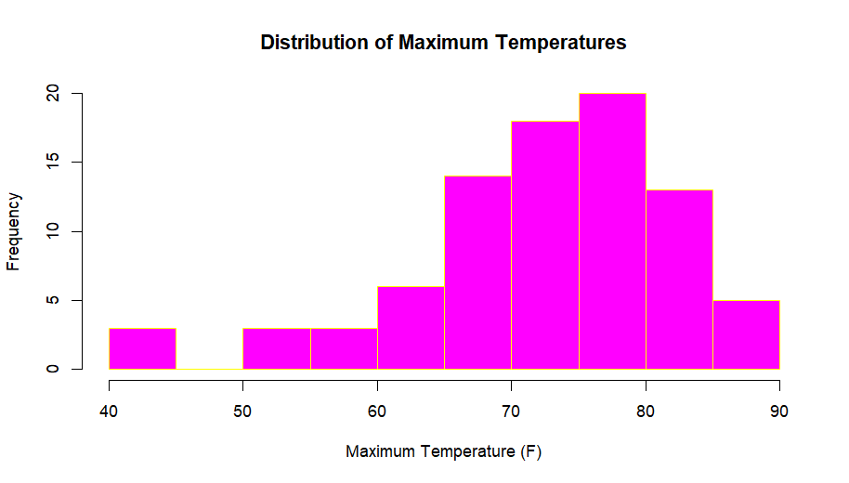
Figure 1. Frequency distribution of maximum recorded temperatures (°F) associated with timber rattlesnake (Crotalus horridus) encounters. Observations occurred at a variety of temperatures, with the highest frequencies recorded between approximately 65–85 °F. Fewer observations occurred at the lower and upper extremes of the recorded temperature range.
Comparisons between detection methods revealed considerable overlap in recorded temperature distributions, although several observations occurred toward the extremes of each distribution (Figure 2). Similarly, comparisons among females, males, and juveniles revealed relatively little variation in mean recorded temperatures, with juveniles exhibiting slightly lower mean temperatures than adults (Figure 3).
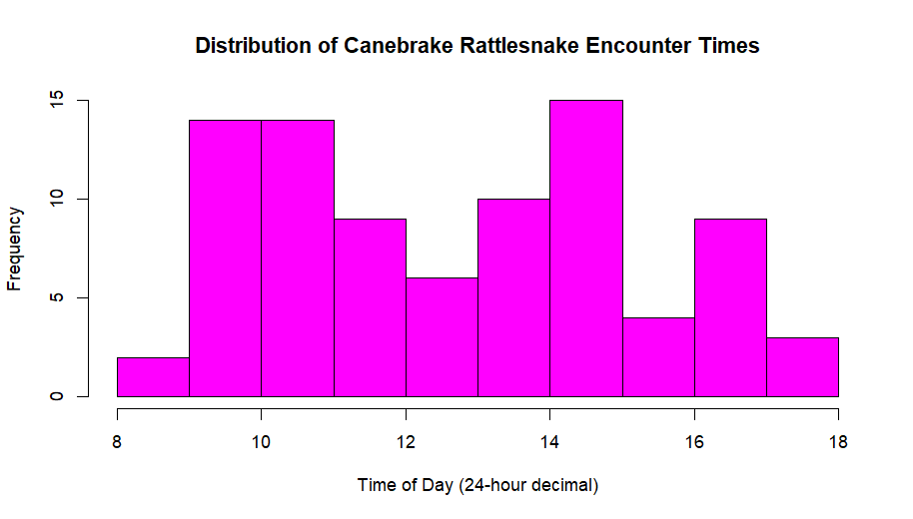
Figure 2. Encounter times are represented using decimal hours on a 24-hour scale, with observations occurring between approximately 0800 and 1800 hours. Encounters were distributed throughout the survey period, with relatively higher frequencies during the late morning and early afternoon.
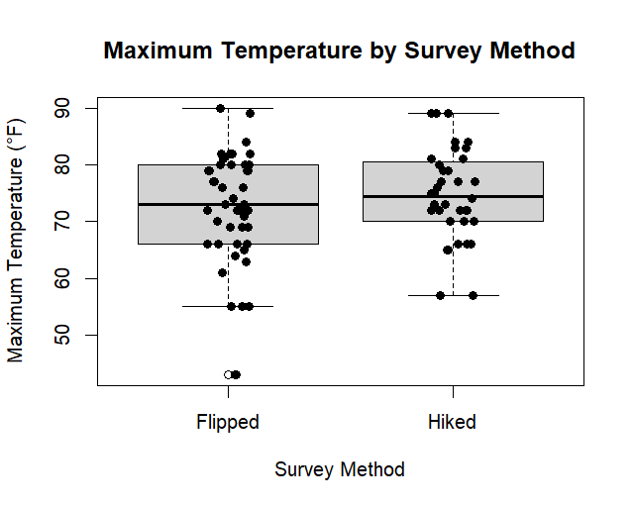
Figure 3. Comparison of maximum recorded temperatures (°F) associated with timber rattlesnake (Crotalus horridus) encounters using two survey methods: flipping artificial cover objects and hiking transects. Both methods exhibited considerable overlap in temperature distributions, although hiking transects had a slightly higher median recorded temperature.
These observations suggest that rattlesnakes utilize a variety of available habitat structures and remain detectable across a relatively broad range of thermal conditions. This work is preliminary and does not include all analysis figures as of this assignment.

